0 &1 Host MGMT

REP_ nic6&7

prod_4&5

8&9 VM mgmt

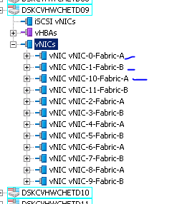

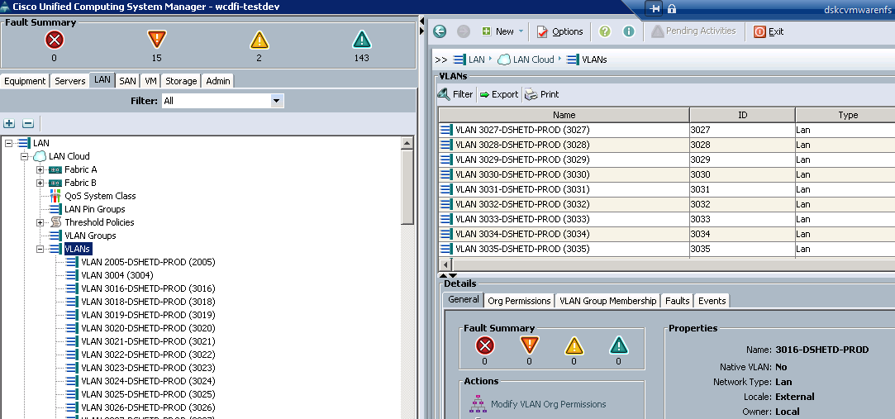

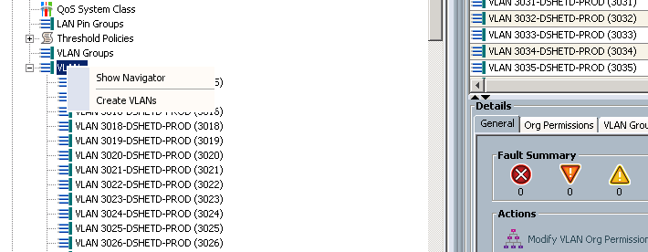

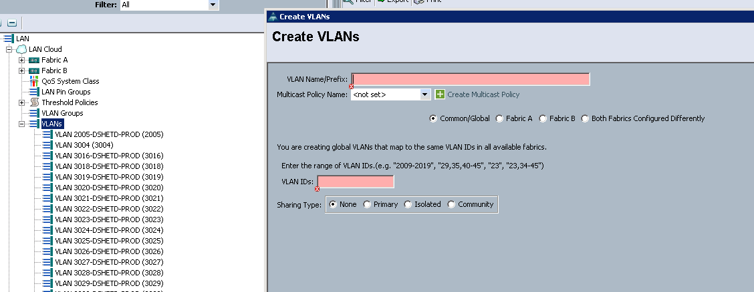

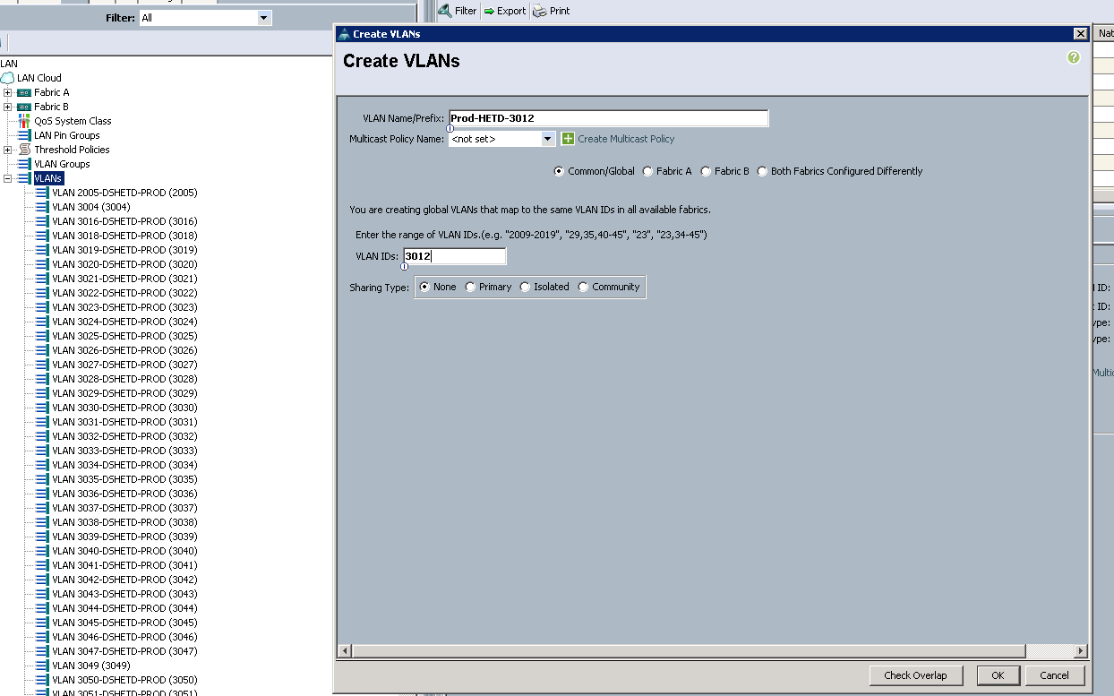

Click overlap

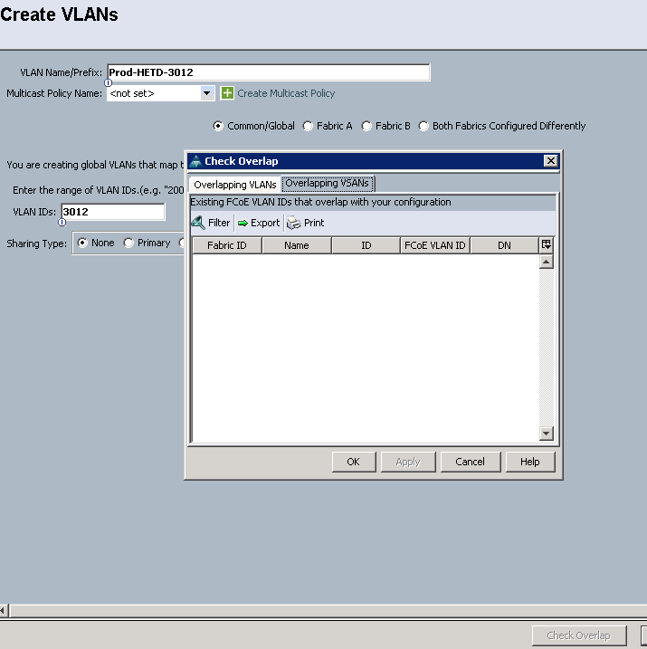

Click ok

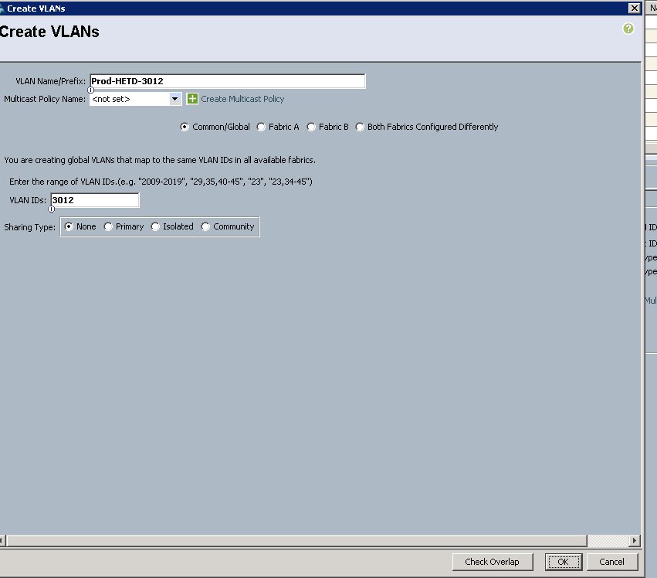

Click ok

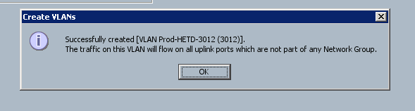

Now go to VNIC Templates

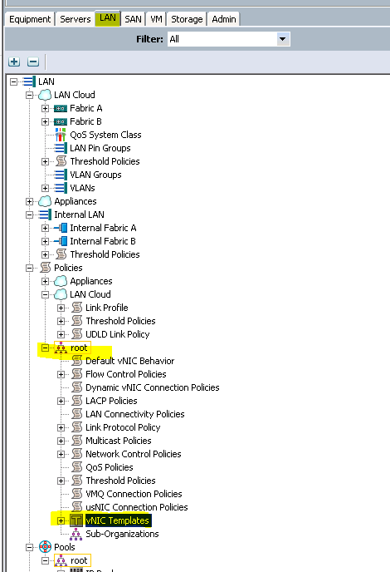

Choose vNIC Template vNIC-4-Fabric-A this is vnic4 on ESXi Host. (redundance vNIC is 5) so same vlans we need to modify on vNIC Template vNIC-5-Fabric-B (this is ESXi NIC 5 on ESXi Host)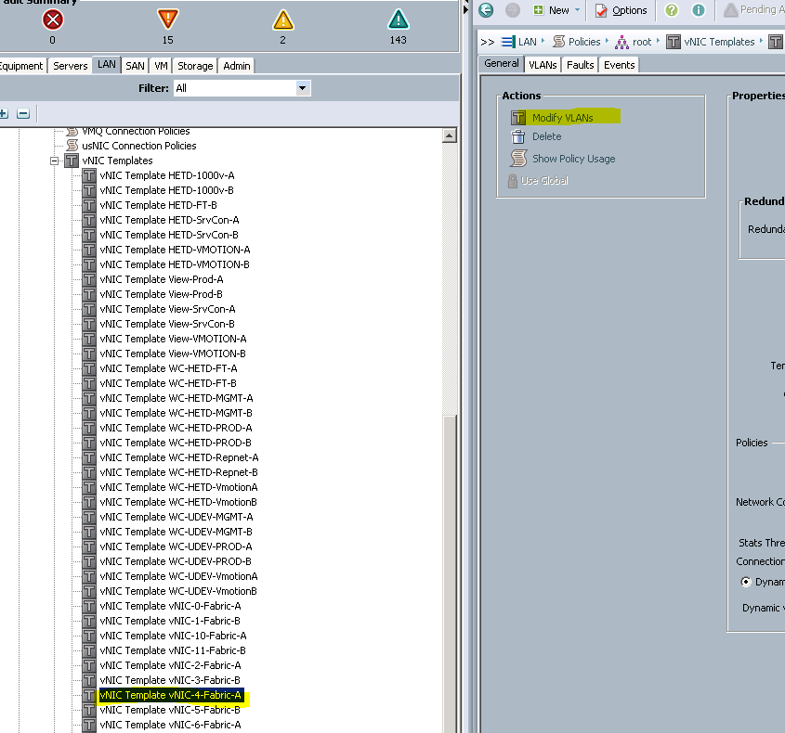

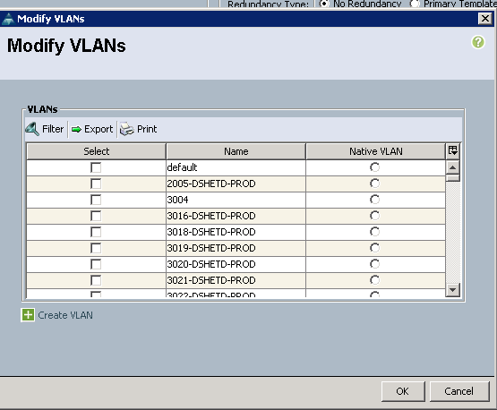

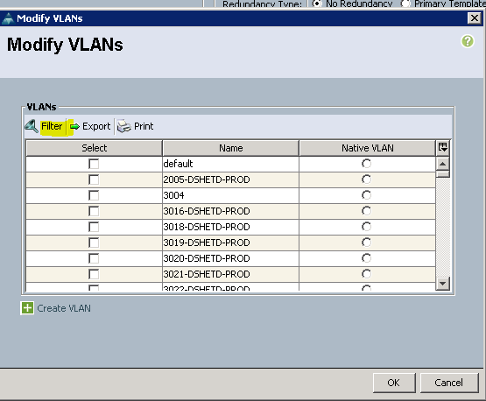

Change name to wild card

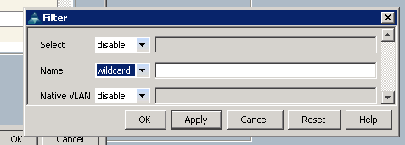

Search your created VLAN

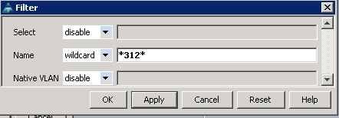

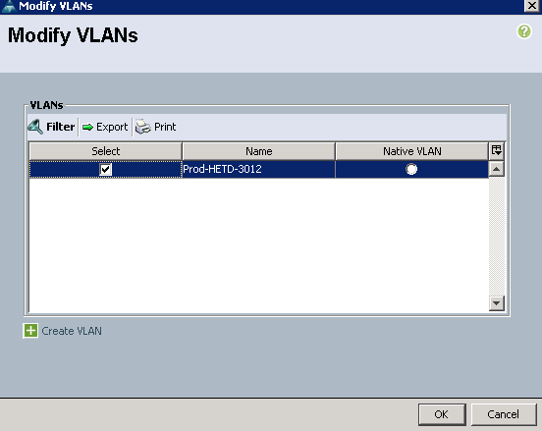

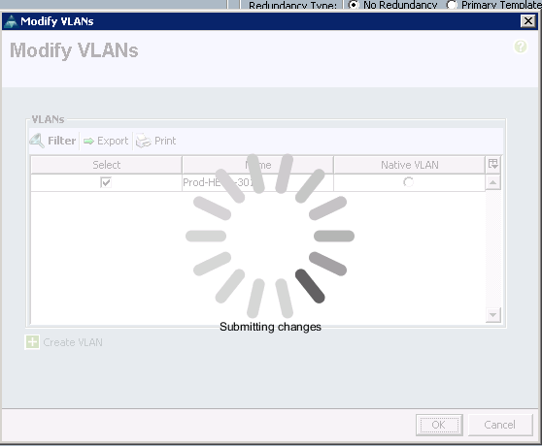

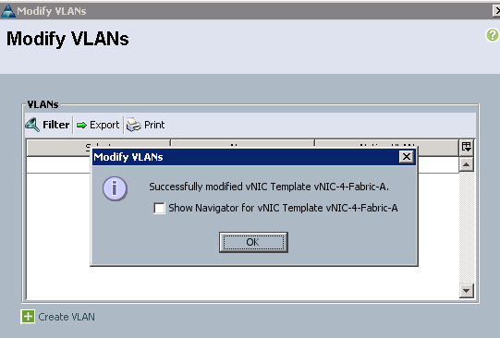

Now choose

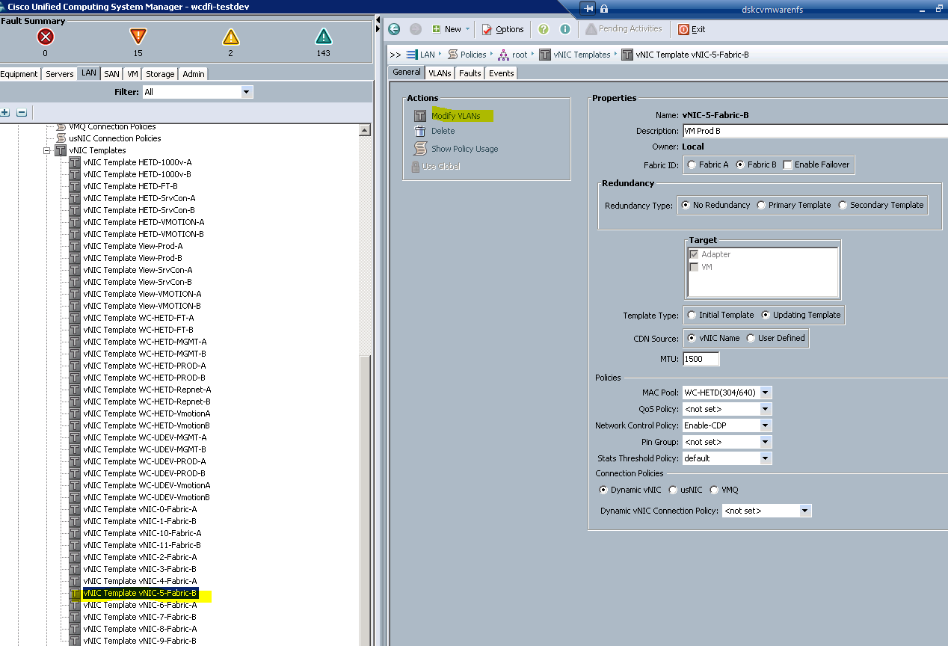

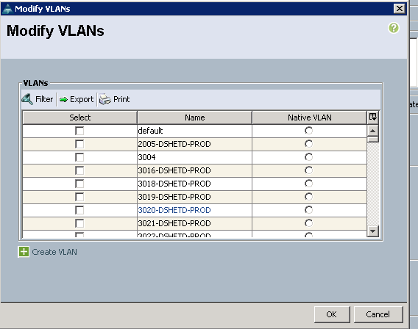

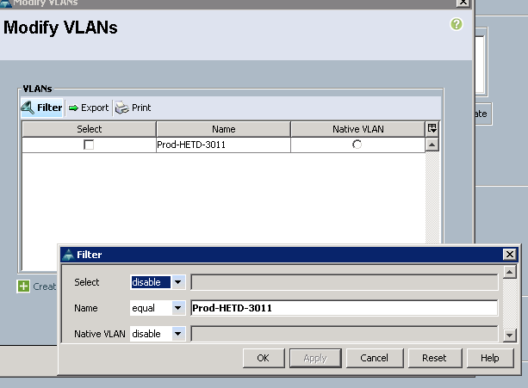

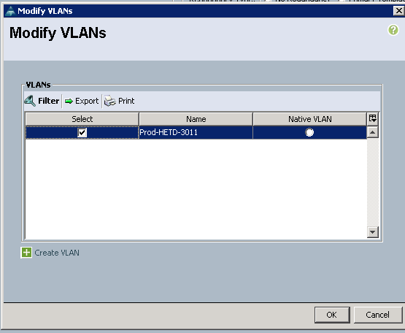

Click ok

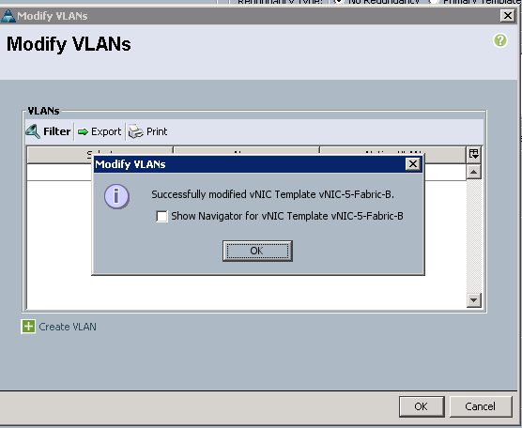

REPNET is ESXi_ nic6&7

Create VLANS first on VLANS from LAN tab than add those VLANS on vNIC Template vNIC-6-Fabric-A & vNIC Template vNIC-7-Fabric-B by modifying

Modify below VLANS on vNIC Template vNIC-6-Fabric-A & vNIC Template vNIC-7-Fabric-B

|  |
| --- |
| Repnet-HETD-3778 |
| Repnet-HETD-3779 |
| Repnet-HETD-3780 |

